Barbe Victor 403715

Gaucher Pierre-louis 103783

Tarea 1

1 – Install anaconda on all devices that will be used to work, explain the installation and the different possible usage

To install anaconda, we go on the official website of anaconda distribution. Then we select the correct version depending on our operating system (windows, mac or linux).

Then we follow the different indications of the anaconda installer, and we accept the privacy asking.

Once anaconda is installed, we can go to the main menu with the different applications that are already pre-installed.

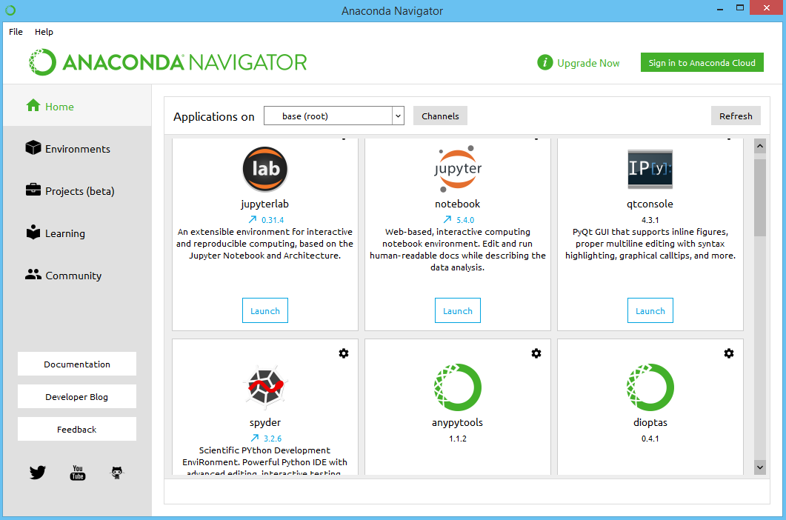

We are now going to explain the different applications that are available on the Anaconda navigator.

Jupyter notebook:

It is an open-source software which was spun off from python in 2014. Its goal is to give a platform that allows to use different programming languages. It can support Python, R and Julia. It is also a mix between a regular text editor that uses Markdown language in order to create a friendly environment that works like a notebook.

R:

It is a statistical programming language and framework, which is used for many applications that require to make statistics. Machine learning is one of them. It is considered as unconventional compared to java or C/C++, but it can run on operating systems like any other language (windows, mac and Linux).

Python:

Python is an interpreted language (compared to other languages like C that are compiled) that is considered as easy to use, and high level (you don’t have to check your memory usage all the time like in C). It provides a lot of libraries for machine learning or stats as an example, but it is relatively slow compared to C or Java.

Spyder:

Spyder is an open-source IDE used for scientific programming in Python. Many libraries are included in this IDE such as NumPy, Pandas, Matplotlib… which are the more common. It includes also open-source libraries/packages. Since its creation in 2009, it is continuously updated, providing for users the last technologies available, fixing bugs and better performances.

It is an IDE designed for scientists and specifically data scientists. It provides many optimized features such as: interactive compilations (run a specific line/file…), real time code introspection (giving information about variables, functions… such as what they do, what’s they receive…) or an included display for graphics with Matplotlib.